**Experiment No.04**

PART A

(PART A: TO BE REFFERED BY STUDENTS)

**Experiment 4**

**A.1 Aim: Design level-1, Level-2 and Level-3 Data flow diagram**

**A.2 Prerequisite:**

**A.3 Outcome:**

DFD shows how the system is actually implemented, either at the moment or how the designer intends it to be in the future. DFD attempts to capture the data flow aspects of a system in a form that has neither redundant nor duplicated.

After completing this experiment, you will be able to:

* Identify external entities and functionalities of any system
* Identify the flow of data across the system
* Represent the flow with Data Flow Diagrams

**A.4 Theory:**

**Dataflow Diagram:**

DFD provides the functional overview of a system. The graphical representation easily overcomes any gap between ’user and system analyst’ and ‘analyst and system designer’ in understanding a system. Starting from an overview of the system it explores detailed design of a system through a hierarchy. DFD shows the external entities from which data flows into the process and also the other flows of data within a system. It also includes the transformations of data flow by the process and the data stores to read or write a data.

A DFD shows what kind of information will be input to and output from the system, where the data will come from and go to, and where the data will be stored. It does not show information about the timing of processes, or information about whether processes will operate in sequence or in parallel.

The highest level, called the context diagram, is only an overview. More detail is typically needed for system analysts. We add detail to a DFD by creating “levels”. The first level added after the context diagram is called level “0”. Each new level breaks apart one process and “decomposes” the single process into a new, more detailed DFD. A complete DFD can have many (up to 6 or 7) levels depending on the complexity of system. Breaking the DFD into levels is referred to as “Decomposition”.

**Explanation of Symbols used in DFD**

**Process:** Processes are represented by circle. The name of the process is written into the circle. The name of the process is usually given in such a way that represents the functionality of the process. More detailed functionalities can be shown in the next Level if it is required. Usually it is better to keep the number of processes less than 7 . If we see that the number of processes becomes more than 7 then we should combine some the processes to a single one to reduce the number of processes and further decompose it to the next level.

**External entity:** External entities are only appear in context diagram. External entities are represented by a rectangle and the name of the external entity is written into the shape. These send data to be processed and again receive the processed data.

**Data store:** Data stares are represented by a left-right open rectangle. Name of the data store is written in between two horizontal lines of the open rectangle. Data stores are used as repositories from which data can be flown in or flown out to or from a process.

**Data flow:** Data flows are shown as a directed edge between two components of a Data Flow Diagram. Data can flow from external entity to process, data store to process, in between two processes and vice-versa.

**Context diagram and leveling DFD:**

We start with a broad overview of a system represented in level 0 diagram. It is known as context diagram of the system. The entire system is shown as single process and also the interactions of external entities with the system are represented in context diagram.

Further we split the process in next levels into several numbers of processes to represent the detailed functionalities performed by the system. Data stores may appear in higher level DFDs.

In a DFD with many levels it’s easy to forget which level you are on. That’s why each level has different numbering for the processes on the diagram. The ‘level’ corresponds to the number of decimal places required to define a process in it. Here’s how it works:

Context Diagram Process labeled “0”

Level 1 Processes labeled 1.0, 2.0, 3.0, .

Level 2 Processes labeled 1.1, 1.2, 1.3, .

Level 3 Processes labeled 1.1.1, 1.1.2,...

**Task to be completed:**

1. **Design Level 0, Level 1 and Level2 for your project.**

**(Use appropriate symbols for Entity, process, dataflow and database )**

Note :

1. External entities only appear in context diagram i.e, only at level 0.
2. Keep number of processes at each level less than 7.
3. Data flow is not possible in between two external entities and in between two data stores.
4. Data cannot flow from an External entity to a data store and vice-versa.

***************************************************************************

**PART B**

(PART B: TO BE COMPLETED BY STUDENTS)

**(Students must submit the soft copy as per following segments within two hours of the practical. The soft copy must be uploaded on the Blackboard or emailed to the concerned lab in charge faculties at the end of the practical in case the there is no Black board access available)**

|  |  |
| --- | --- |
| Roll No. B228 | Name: Pranav Kolhe |
| Program: Btech | Division: CS |
| Batch: A | Date of Experiment: |
| Date of Submission: | Grade: |

**B.1 Tasks given in PART A to be completed here**

*(****Students must write the answers of the task(s) given in the PART A)***

**Level-0: -**

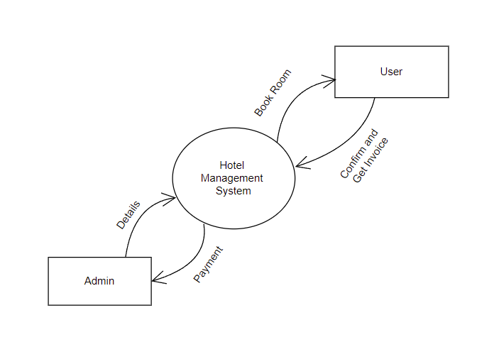

**Level-1: -**

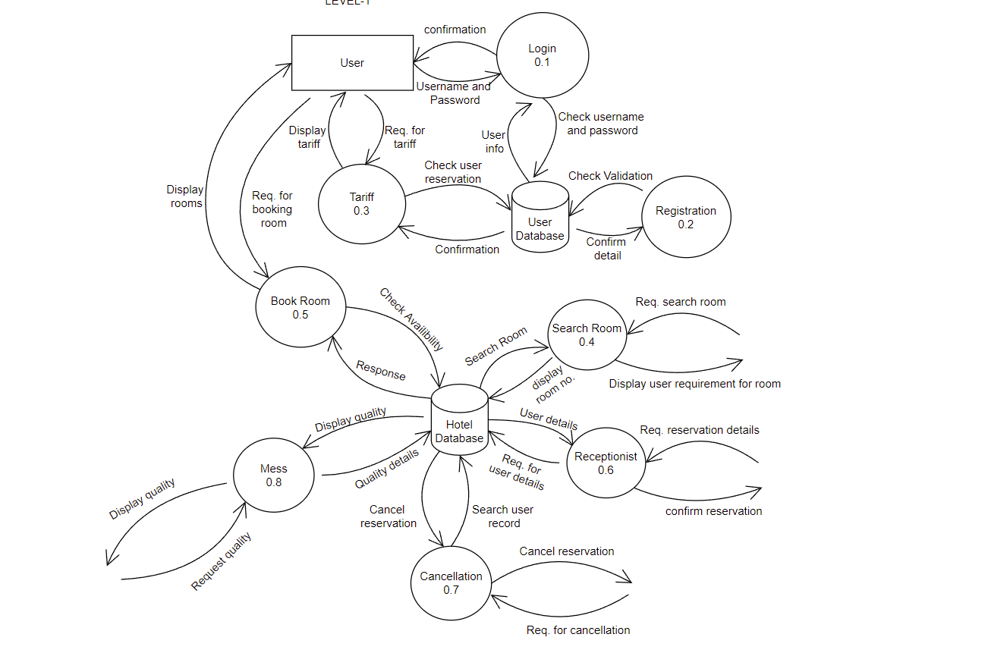

**Level-2: -**

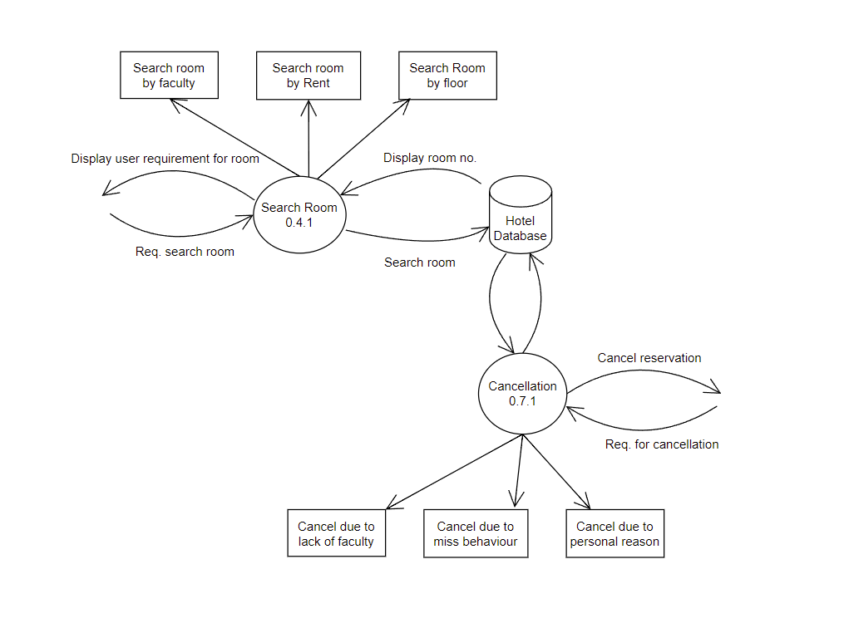

**B.2 Observations and Learning:**

*(****Students must write the observations and learning based on their understanding built about the subject matter and inferences drawn)***

**Designed Level 0, Level 1 and Level 2 DFD for my project.**

**B.3 Conclusion:**

*(****Students must write the conclusive statements as per the attainment of individual outcomes listed above and learning/observation noted in section B.2)***

**This experiment was performed successfully.**

**B.4 Question of curiosity:**

**1. A DFD represents**

Flow of control http://vlabs.iitkgp.ernet.in/se/isad_static/isad/images/transparent_2x2.png

Flow of data http://vlabs.iitkgp.ernet.in/se/isad_static/isad/images/transparent_2x2.png

Both the above http://vlabs.iitkgp.ernet.in/se/isad_static/isad/images/transparent_2x2.png

Neither one http://vlabs.iitkgp.ernet.in/se/isad_static/isad/images/transparent_2x2.png



**2. Which is not a component of a DFD?**

Data flow http://vlabs.iitkgp.ernet.in/se/isad_static/isad/images/transparent_2x2.png

Decision http://vlabs.iitkgp.ernet.in/se/isad_static/isad/images/transparent_2x2.png

Process http://vlabs.iitkgp.ernet.in/se/isad_static/isad/images/transparent_2x2.png

Data store http://vlabs.iitkgp.ernet.in/se/isad_static/isad/images/transparent_2x2.png



**3. How many processes are present in level-0 or context diagram?**

0 http://vlabs.iitkgp.ernet.in/se/isad_static/isad/images/transparent_2x2.png

1 http://vlabs.iitkgp.ernet.in/se/isad_static/isad/images/transparent_2x2.png

2 http://vlabs.iitkgp.ernet.in/se/isad_static/isad/images/transparent_2x2.png

3 http://vlabs.iitkgp.ernet.in/se/isad_static/isad/images/transparent_2x2.png



**4. External entities can appear in a DFD**

At any level http://vlabs.iitkgp.ernet.in/se/isad_static/isad/images/transparent_2x2.png

Only at level-0 http://vlabs.iitkgp.ernet.in/se/isad_static/isad/images/transparent_2x2.png

Only at level-1 http://vlabs.iitkgp.ernet.in/se/isad_static/isad/images/transparent_2x2.png

Either at level-0 or at level-1 http://vlabs.iitkgp.ernet.in/se/isad_static/isad/images/transparent_2x2.png



**5. Data flow in a DFD is not possible in between**

Two processes http://vlabs.iitkgp.ernet.in/se/isad_static/isad/images/transparent_2x2.png

Data store and process http://vlabs.iitkgp.ernet.in/se/isad_static/isad/images/transparent_2x2.png

External entity and data store http://vlabs.iitkgp.ernet.in/se/isad_static/isad/images/transparent_2x2.png

Process and external entity http://vlabs.iitkgp.ernet.in/se/isad_static/isad/images/transparent_2x2.png

Answers: -

1. B
2. B
3. B
4. B
5. C

***************